
Business Processes in Management
Accounting in SAP S/4HANA

PARTICIPANT HANDBOOK
INSTRUCTOR-LED TRAINING
Course Version: 08
Course Duration: 5 Day(s)
e-book Duration: 17 Hours 45 Minutes
Material Number: 50144966



@ 2018 SAP SE or an SAP affiliate company All rights reserved.
No part of this publication may be reproduced or transmitted in any form or for any purpose without the express permission of
SAP SE or an SAP affiliate company.
SAP and other SAP products and services mentioned herein as well as their respective logos are trademarks or registered
trademarks of SAP SE (or an SAP affiliate company) in Germany and other countries. Please see http://global12 sag.com/
§Ql’QQl'3t§'QFl/lﬁgﬁl/QQQ¥tlgltt/lHdQX egx for additional trademark inf0rmatlOn and nOtlC€S.
Some software products marketed by SAP SE and its distributors contain proprietary software components of other software
vendors.
National product specifications may vary.
These materials are provided by SAP SE or an SAP atnliate company for informational purposes only. without representation or
warranty of any kind, and SAP SE or its affiliated companies shall not be liable for errors or omissions with respect to the materials.
The only Warranties for SAP SE or SAP affiliate company products and services are those that are set forth in the express Warranty
statements accompanying such products and services. it any Nothing herein should be construed as constituting an additional
warranty.
in particular, SAP se OI’ ltS affiliated companies have no Obligation to pursue any course of Business outlined ll'\ tl'\lS document or
any related presentation. or to develop or release any functionality mentioned therein This document. or any related presentation.
and SAP SE‘s or its affiliated companies‘ strategy and possible future developments, products. and/or platlorm directions and
functionality are all subiect to change and may be changed by SAP SE or its affiliated companies at any time for any reason without
notice. The information in this document is not a commitment. promise. or legal obligation to deliver any material. code. or
functionality. All forward-looking statements are sublect to various risks and uncertainties that could cause actual results to differ
materially from expectations. Readers are cautioned not to place undue reliance on these forwardlooking statements. which
speak only as of their dates. and they should not be relied upon In making purchasing decisions

Amencan Enghsh |s the standard used 1n thxs handbook
The following typographlc conventions are also used_
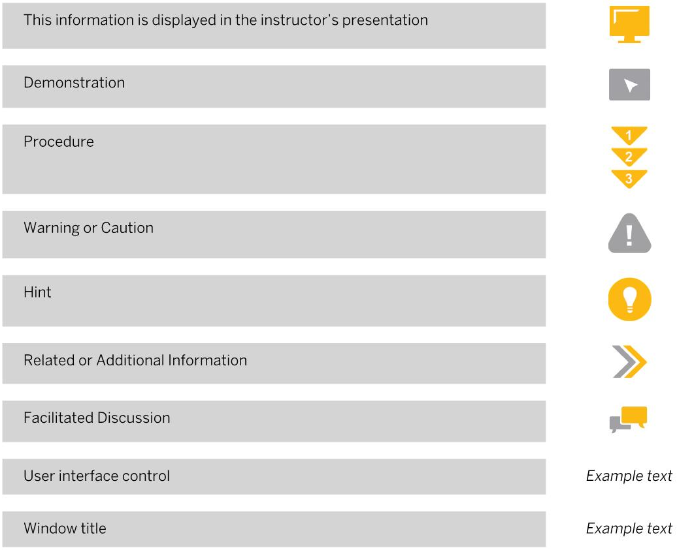
This informatwon is dlsplayed in the instructor's presentahon
Demonstratron
Procedure
Warning or CBUUOH
Hin
Related or Addmonal lnformahon
Facllitated Discussion
User interface contro
Window title

Course Overview
Unit 1:
Unit 2
Unit 3:
Unit 4:
Unit 5:
SAP S/4-HANA Overview
Lesson: Introducing SAP HANA and SAP S/4HANA
Lesson: Introducing SAP Fiori
Management Accounting Overview
Lesson: Positioning of Financial Accounting and Management
Accounting
Lesson: Defining Specific Tasks of Management Accounting
Components
Organizational Units and Master Data in Management
Accounting
Lesson: Identifying Organizational Units Used in Management
Accounting
Lesson: Maintaining Master Data in Overhead Management
Accounting
Lesson: Maintaining Additional Master Data in Overhead
Management Accounting
User Interface and Analytics in Management Accounting
Lesson: Understanding S/4HANA Financial Reporting
Lesson: Using the SAP List Viewer (Optional)
Lesson: Using Drilldown Reports (Optional)
Planning in Management Accounting
Lesson: Identifying Planning and Cost Allocation Methods
Lesson: Identifying Planning Options in Overhead Management
Accounting
Lesson: Optimizing Planning in Overhead Management Accounting
Lesson: Using the New Planning Option

vii Course Overview

1 Unit 1: SAP S/4HANA Overview
2 Lesson: Introducing SAP HANA and SAP S/4HANA
10 Lesson: lntroducmg SAP Fion

15 Unit 2: Management Accounting Overview
16 Lesson: Positioning of Financial Accounting and Management
Accounting
28 Lesson: Defining Specific Tasks of Management Accounting
Components

53 Unit 3: Organizational Units and Master Data in Management
Accounting
54 Lesson: Identifying Organizational Units Used in Management
Accounting
59 Lesson: Mamtaining Master Data \n Overhead Management
Accounting
65 Lesson: Maintarning Addxtional Master Data \n Overhead
Management Accountmg

73 Unit 4: User Interface and Analytics in Management Accounting
74 Lesson: Understanding S/4HANA Financial Reporting
89 Lesson: Using the SAP L1stVlewer(Optiona\)
91 Lesson: Using Drilldown Reports (Optional)

97 Unit 5: Planning in Management Accounting
98 Lesson: Identifying Planning and Cost Allocation Methods
100 Lesson: Identifying Planning Options in Overhead Management
Accounting
111 Lesson: Optimizing Planning in Overhead Management Accounting
118 Lesson: Using the New Planning Option

130 Unit 6: Integrated Planning Process in Management Accounting
131 Lesson: Integrating Sales Planning witn Overhead Management
Planning
137 Lesson: Integrating Overnead Management Planning with Business
Plans
151 Lesson: Identifying the Integrated Planning Cycle for Service
Industries
153 Lesson: Identifying the Integrated Planning for Profit Center
Accounting

161 Unit 7: Characteristics of Accounting Logic Integration
162 Lesson: Identifying Postings from Other Appiications
168 Lesson: Posting from Financiai Accounting and SAP HCM
171 Lesson: Creating Postings frorn Material Management
175 Lesson: Posting to Statistical Orders and Real Orders

186 Unit 8: Daily Postings in Management Accounting
187 Lesson: Posting Actual Costs in Overhead Management Accounting
191 Lesson: Budgeting Proiects
194 Lesson: Analyzing Cost Object Controlling Scenarios
201 Lesson: Creating and Analyzing Postings in a Make—t0—Stock
Environment
206 Lesson: Creating and Analyzing Postings for Selling Make»to-Stock
Goods
212 Lesson: Creating and Analyzing Postings for Selling Services

220 Unit 9: Period-End Closing Aspects of Management Accounting
221 Lesson: Performing Period-End Closing for Overhead Cost
Controlling
240 Lesson: Performing Periodic Cost Allocations to Product Cost
Controlling
244 Lesson: Performing Final Costing for Product Cost Controlling
249 Lesson: Managing Profit Analysis in Management Accounting


TARGET AUDIENCE
This course is intended for the foliowing audiences
- Application Consuitant
- Proiect Stakeholder
- Super / Key / Power User
- iT Support
- PFC/j€Ct Manager

